What exactly is changing and when will this occur?
Effective April 1, 2023, VAST Insurance will become the agent of record for your policy. They will provide all policyholder customer services including renewal, invoicing, and payment processing.

Why is Paul Goebel Group making this change?
When our two Professional Liability Account Managers, Kate Bystry and Joan La Franca announced their upcoming retirement, we considered several options that would provide you, the policyholder, with the highest level of service during a transition period as well as long term. We chose to move your policy to VAST Insurance due to their history of providing best in class customer service and a commitment to the Michigan professional liability market.

Will my current coverage be affected by this change?
There will be no change to your current coverage or your policy’s expiration date. Your policy will remain with the same underwriting carrier.

Is there anything I need to do?
If your policy renewal date is between January 1st and April 31st, 2023, Paul Goebel Group and VAST Insurance will work together to ensure a smooth renewal process during the transition.
If your policy renews after May 1^{st,} you will work directly with VAST Insurance to complete the renewal process.

If I have any questions, who should I contact?
You can continue to contact Kate or Joan during the transition period through March 31st. After that April 1st. your direct contact at VAST Insurance will be Alec Fruin or Cameron Leedle. See attached document highlighting VAST for all their contact information.
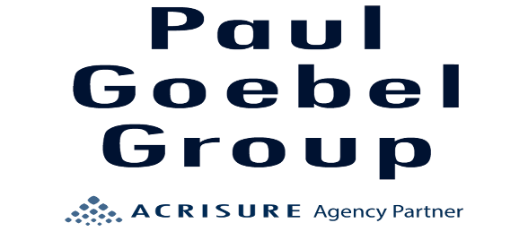
800-632-4591

